**Appendix C: Classroom Rules**

1. [](http://www.google.com/imgres?q=follow+directions&um=1&hl=en&biw=1366&bih=644&tbm=isch&tbnid=2JrmHS0rbo58IM:&imgrefurl=http://courses.dsu.edu/learningtools/survey/mod_quest_pictures.htm&docid=y9yQxcXuOmGllM&w=120&h=119&ei=WkBtTqvIEcXl0QH09aTkBA&zoom=1&iact=rc&dur=58&page=2&tbnh=95&tbnw=96&start=21&ndsp=23&ved=1t:429,r:12,s:21&tx=73&ty=49)Follow the teacher’s directions.



1. Raise your hand to talk or ask for help.

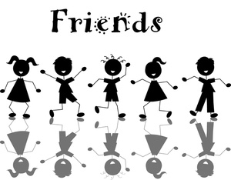

1. Keeps your body parts, objects and unkind words to yourself.

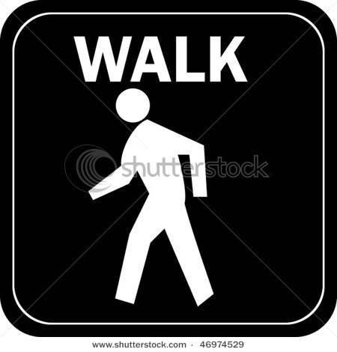

1. Use your walking feet inside.



1. Work quietly in your seat.